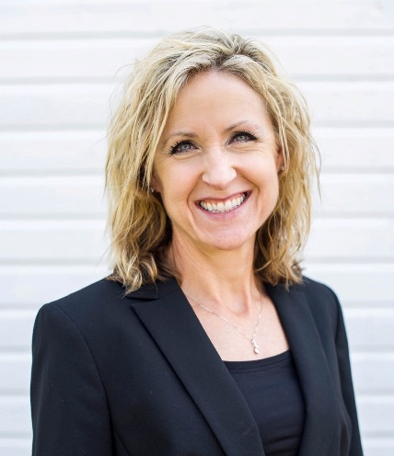
Cheryl A. Schow
Sr. Manager, Short Line Development
Network Economic & Industrial Development
Union Pacific Railroad
1400 Douglas Street
Omaha, NE 68179
402-544-5832
caschow@up.com

Cheryl was hired by Union Pacific Railroad (UPRR) in September, 2003, as the Regional Manager, Industrial Development. Responsibilities included guidance, support and rail project management for businesses looking to establish rail service on Union Pacific in a 4-state area. In that role, she facilitated UP’s LAND Banking program, and assisted in the development of UP’s Site Solutions Tool an on-line searchable database for rail accessible properties.

Cheryl is now the Sr. Manager, Short Line Development, with UPRR. In that role, she leads a small team in serving the transportation needs of Class III Short Line Railroads connecting to UPRR within a 14-state area. Her team ensures a high level of customer service, provides marketing and commercial development advice and support of Short Line development. Her team actively assists with business growth opportunities and expansion efforts along the Short Line routes.

Prior to Union Pacific, she served in several economic and community development positions in western Nebraska including the City of Ogallala, Keith County’s Economic Development Corporation, NAF Multicultural Human Development Corporation and West Central Nebraska Development District.
Cheryl holds a Bachelor of Arts Degree in Psychology and a Masters in Community and Regional Planning from the University of Nebraska Lincoln.

She and her husband Kyle have two children, Bailee and Ben. Cheryl is passionate about health care and fitness; homelessness and food waste recovery; facilitating women in leadership roles in corporate America and, most importantly, her faith.

